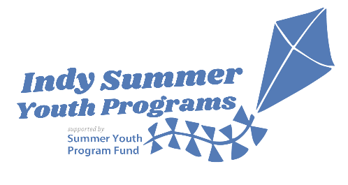

NARRATIVE GRANT REPORT
2020 Indy Summer Youth Programs supported by Summer Youth Program Fund
Report templates are available at: http://indysummeryouthprograms.org/
Due: September 30, 2020 by 4PM

Responsible grantee organization:

Address:

City, State & Zip:

Person completing the final report/title:

Phone:

E-mail address:

Program name:

Program location (if different than responsible organization above):

Address:

City, State & Zip:

Program type (list all that apply: Academic Achievement, Daily, Enhancement/Special Project, Youth Employment or Overnight):
Program delivery (in-person, virtual or hybrid):

Dates of program operation:

Signature of Executive Director or Board Chair:

Date report completed:

NARRATIVE REPORT
(Suggested report length of 3-4 pages)

Please indicate if programming was delivered in-person, virtually or a hybrid of both.

In-person Virtually Hybrid

Indicate how many days or weeks the program was available and for how many hours each day. Provide an overview of your program and the nature of program activities. Please describe if activities had to be adapted, redesigned or entirely recreated in light of COVID.

Please describe specific partnerships that you developed to augment recruitment of youth, enhance program delivery, expand activities, etc. Indicate if any of these partnerships were new.

Please list the number of youth served, by age, where appropriate. If participation was hard to track/gauge, please provide your best assessment of program reach.

Please describe the program activities that you believe benefitted youth most. This may be the result of program assessments, unsolicited feedback garnered from youth or their parents/caretakers or based on the input of program staff.

Knowing this spring and summer resulted in unprecedented challenges to your organization and your program planning and implementation, please describe lessons learned that will be instructive to you and your team as you plan future programs.

Please describe what, if any, technical assistance, communities of practices and/or other program support you sought or participated in this summer.

Note: The Narrative Report, Financial Report and Registration & Attendance Report (two separate tabs on the accompanying Excel document) are due September 30, 2020 by 4PM.

Please mail or deliver one signed original copy of the three reports to:

Attn: Indy Summer Youth Programs supported by Summer Youth Program Fund
Lilly Endowment Inc.
2801 North Meridian Street
P.O. Box 88068
Indianapolis, IN 46208-0068

AND

Email as two separate documents the Narrative Grant Report and the Financial Report and Registration & Attendance Report (please send as an Excel document; do not save and send as a PDF) with the organization name in the subject of the email to: grantreports@cicf.org.

If you have any questions, please feel free to contact:
Indy Summer Youth Programs supported by Summer Youth Program Fund
The Indianapolis Foundation
Phone: 317.631.6542 x 138
Email: HectorMH@cicf.org

